**Part 1**  
Run the script and screenshot the result in step 5:

Change the line of code in Step 6 on page 251. Rerun the script and screenshot the result:

**Part 2**

Run the script and screenshot the result of step 3:

Rerun the script after disabling the reporting of notices and screenshot the result:

Replace the error_reporting( ) code on line 15 with error_reporting(E_ALL &  
~E_NOTICE); :

Rerun the script with the error reporting being set to 0 and screenshot the result:

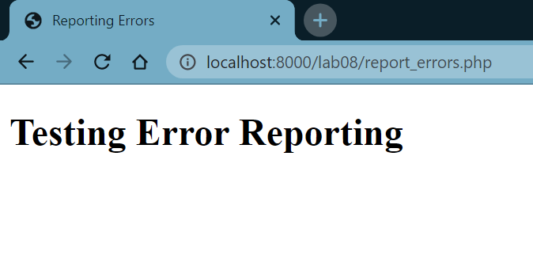

**Part 3**

Run the script and screenshot the results of that script:

Change the value of LIVE to true. Rerun the script and screenshot the results of that script.:

Under the line $message .= print_r($e_vars, 1); (on line 22), add the following line of code:  
$message .= error_log("We have an error. Check the Server", 1, "jdaly@student.rcc.edu");:

*Unfortunately, I was unable to get email working.*

